
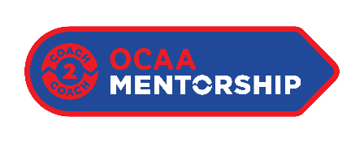
OCAA Mentorship Program – School Application

Please complete the following:
- School:
- Department:
- Department contact information
  - Name:
  - Role:
  - Email:
  - Phone Number:
- Sport applying for:

Please answer each question below. (200 words or less per question)
NEEDS ASSESSMENT:
- Please tell us about your apprentice & mentor and how they make good candidates for this program?

- Please outline how the support of this program will have a measurable impact on the apprentice coach’s development?

- How does this program align with your athletic departments strategic priorities specific to coach development?

SUSTAINABILITY & FUNDING REALLOCATION:
- Please outline what the pathway for success looks like for your apprentice coach beyond the scope of this program?

- Please outline if/how sustainable the new apprentice coach position will be and if there is potential for future funding commitments beyond the scope of this project.

- If the $2000 funding is covering an existing honorarium, how will the savings be re-invested?

- What is the total honorarium amount for this Apprentice coach position?

INSTITUTION / ATHLETIC DEPARTMENT SUPPORT:
- Outside of the programs contributions, in what additional ways will the school/athletic department support the Apprentice and the Mentorship program?

- The mentorship program aside, in what ways does the school/athletic department invest in the development of quality coaching within its programs?

EVALUATION & PROGRAM SUCCESS?
- How will you measure the success of this program?

- How will you ensure that this program is successful for the mentor, the mentee, and your athletic department?

